Sofia University
Department of Mathematics and Informatics
Course : OO Programming C#.NET
Student Name:
Lab No. 11
Submit the all C# .NET files developed to solve the problems listed below. Use comments and Modified-Hungarian notation.

Problem No.1a
Create a program that stores student grades in a file (grades.ser). The file should contain the name, ID number, class taken and grade of every Student (grades are integers in the interval [0, 100]).
Allow the user to load a grade file and display its contents in a read-only TextBox. The entries should be displayed in the following format:
LastName, FirstName: ID# Class Grade
We list some sample data below:
Jones, Bob: 1 "Introduction to Computer Science" 95
Johnson, Sarah: 2 "Data Structures" 82
Smith, Sam: 3 "Data Structures" 75
Write class Student and allow the program to use objects of class Student that can be serialized to and deserialized from a file. (Study the attached SerializeWithAppend.rar to learn how to append records, while serializing objects)
Create and use a User Control to read/ write user input/ file records
Problem No.1b

Modify the attached P1bCreditInquiryWithText.rar project (Fig19_12 from Lecture 11) execute a inquiry of Record objects serialized in a file. Thus, instead of a StreamReader the application must use a BinaryFormatter. Additionally, there should be an extension method Lines() for class BinaryFormatter, where the custom iterator in that method must return IEnumerable<Record> instead of IEnumerable<string>. Accordingly, provide a second argument of type FileStream in the Lines() method allowing to deserializes Record objects in the custom iterator..
Use the attached P1bCreateFile.rar project to create a file with serialized objects and test your CreditInquiry application
Problem No.1c

Modify the solution of Problem 1b to use LINQ statements with lambda expressions. Add the following functionality in terms of using Func and LINQ:
- Display the contents of the file sorted in descending order of the Balance property of the Record objects
- Display the contents of the file , where the Balance property is in a given interval of values read from textboxes in the user interface
Employ the following block of code to get a collection of the deserialized records
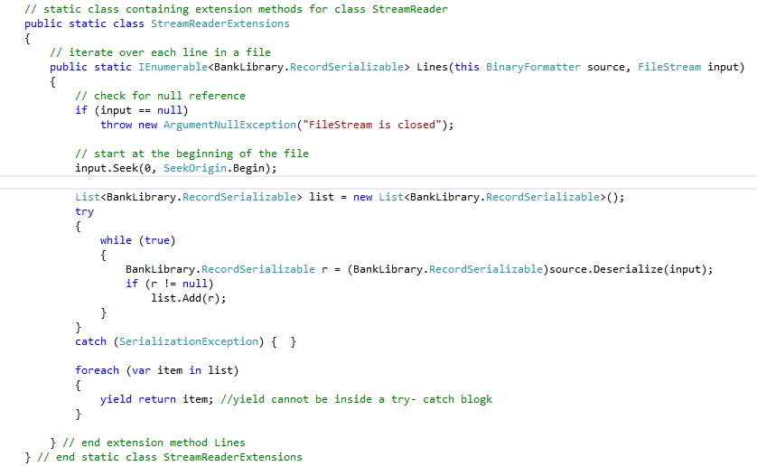to process the deserialized objects using PLINQ method ForAll()
- Add an interest rate of 2% to the balances of the deserialized objects
- Note that
double mean = source.AsParallel().Average();
and write a PLINQ query to display in the GUI the Record objects with balance above the average

Problem No.2a
Create a 3- tier .NET application comprising the following:
- business logic tier – a class representing user records (data members – username, password) – inherit EventArgs and make the class serializable
- interface tier- a UserControl component that displays a set of pairs (Label, Box) and a Button “OK” underneath . Define a custom event allowing to send the data (the user records) collected with the user control
- Application tier with the UserControl object and two buttons “Open” and “Close”. Button “Open” opens a filestream and button “Close” closes the filestream. Clicking on the button “OK” in the usercontrol writes to the filestream the user records as binary serialized.
Problem No.2b
Modify the CreateFileSequentialAccessFile application (study the attached sample code CreateFileSequentialAccessFile.Rar) given in Lecture 11 as follows:
- Replace the BankUIForm with a User Control (UC) with the same functionality as BankUIForm.
- Add to three buttons to that User control.
- Provide user defined Click events for the buttons allowing the client of the UC to decide how to handle this event
- Provide properties for the Buttons allowing the UC client to define the text displayed on each button, to enable or disable the buttons, as well as, to hide and show a button
- Add the UC to a Class library as a Visual control
- Consume the UC in the CreateFileSequentialAccessFile application, retaining the same functionality as in the original application, where the buttons should be part of the UC functionality and not part of the data members of the CreateFileForm.
Problem No.3
Figure 8.8 (attached to the Lab file) contains an array of survey responses that is hard coded into the program. Suppose we wish to process survey results that are stored in a file. First, create a Windows Form that prompts the user for survey responses and outputs each response to a file. Use Stream-Writer to create a file called numbers.txt. Each integer should be written using method Write. Then add a TextBox that will output the frequency of survey responses – use a Dictionary class, LINQ queries and class Func to display averages, frequency counts. You should modify the code in Fig. 8.8 to read the survey responses from numbers.txt. The responses should be read from the file by using a StreamReader. Class string’s split method should be used to split the input string into separate responses, then each response should be converted to an integer. The program should continue to read responses until it reaches the end of file. The results should be output to the TextBox. (Solve the problem analogically to Fig19_12 from Lecture 11а, the code is attached to the lab)
Problem No.4

Write a C#.NET Windows application that displays a Registration form. It collects the following data: (to get an idea see Fig. 18.23 from the textbook)
- the user name- it should be containing ONLY letters a- z (upper or lower case) and at least 2 such letters
- the user phone number- it should be of the format (9999) (9999999) i.e. a two groups of digits (4 and 7, respectively) surrounded by parenthesis.
- The birthday of the user- it should be a legal date. Use a Calendar date picker control to ensure correct user input. The user must be at least 22 years old to be a valid user.
- The email address of the user- it should be a correct email address (for instance, test it with my email address)
The above text fields should be not left empty (indicate it on the form for the convenience of the user) and validated using regular expressions (with the exception of the Birthday field, which should be validated as a Date for the given constraint in terms of years) by clicking a button “Submit” included on the Registration form. In case of wrong user input, an ErrorProvider control with appropriate Tooltip error message should provide full details of the errors in the user input. (For using ErrorProvider study the attached Ch_16ValidationAll.rar)

Sample File operations:
StreamWriter and StreamReader write characters to and read characters from streams. The following code example opens the log.txt file for input, or creates the file if it does not already exist, and appends information to the end of the file. The contents of the file are then written to standard output for display.
using System;
using System.IO;
class DirAppend
{
public static void Main(String[] args)
{
StreamWriter w = File.AppendText("log.txt");
Log ("Test1", w);
Log ("Test2", w);
// Close the writer and underlying file.
w.Close();
// Open and read the file.
StreamReader r = File.OpenText("log.txt");
DumpLog (r);
}
public static void Log (String logMessage, TextWriter w)
{
w.Write("\r\nLog Entry : ");
w.WriteLine("{0} {1}", DateTime.Now.ToLongTimeString(),
DateTime.Now.ToLongDateString());
w.WriteLine(" :");
w.WriteLine(" :{0}", logMessage);
w.WriteLine ("-------------------------------");
// Update the underlying file.
w.Flush();
}
public static void DumpLog (StreamReader r)
{
// While not at the end of the file, read and write lines.
String line;
while ((line=r.ReadLine())!=null)
{
Console.WriteLine(line);
}
r.Close();
}
}

using System;
using System.IO;

class Test
{
public static void Main()
{
try
{
// Create an instance of StreamReader to read from a file.
// The using statement also closes the StreamReader.
using (StreamReader sr = new StreamReader("TestFile.txt"))
{
String line;
// Read and display lines from the file until the end of
// the file is reached.
while ((line = sr.ReadLine()) != null)
{
Console.WriteLine(line);
}
}
}
catch (Exception e)
{
// Let the user know what went wrong.
Console.WriteLine("The file could not be read:");
Console.WriteLine(e.Message);
}
}
}
The following code example shows a simple way to write text to a text file.
using System;
using System.IO;

class Test
{
public static void Main()
{
// Create an instance of StreamWriter to write text to a file.
// The using statement also closes the StreamWriter.
using (StreamWriter sw = new StreamWriter("TestFile.txt"))
{
// Add some text to the file.
sw.Write("This is the ");
sw.WriteLine("header for the file.");
sw.WriteLine("-------------------");
// Arbitrary objects can also be written to the file.
sw.Write("The date is: ");
sw.WriteLine(DateTime.Now);
}
}
}
The following code example creates a new text file and writes a string to it.
using System;
using System.IO;
public class TextToFile
{
private const string FILE_NAME = "MyFile.txt";
public static void Main(String[] args)
{
if (File.Exists(FILE_NAME))
{
Console.WriteLine("{0} already exists.", FILE_NAME);
return;
}
StreamWriter sr = File.CreateText(FILE_NAME);
sr.WriteLine ("This is my file.");
sr.WriteLine ("I can write ints {0} or floats {1}, and so on.",
1, 4.2);
sr.Close();
}
}
The BinaryWriter and BinaryReader classes are used for writing and reading data, rather than character strings. The following code example demonstrates writing data to and reading data from a new, empty file stream (Test.data). After creating the data file in the current directory, the associated BinaryWriter and BinaryReader are created, and the BinaryWriter is used to write the integers 0 through 10 to Test.data, which leaves the file pointer at the end of the file. After setting the file pointer back to the origin, the BinaryReader reads out the specified content.
using System;
using System.IO;
class MyStream
{
private const string FILE_NAME = "Test.data";
public static void Main(String[] args)
{
// Create the new, empty data file.
if (File.Exists(FILE_NAME))
{
Console.WriteLine("{0} already exists!", FILE_NAME);
return;
}
FileStream fs = new FileStream(FILE_NAME, FileMode.CreateNew);
// Create the writer for data.
BinaryWriter w = new BinaryWriter(fs);
// Write data to Test.data.
for (int i = 0; i < 11; i++)
{
w.Write( (int) i);
}
w.Close();
fs.Close();
// Create the reader for data.
fs = new FileStream(FILE_NAME, FileMode.Open, FileAccess.Read);
BinaryReader r = new BinaryReader(fs);
// Read data from Test.data.
for (int i = 0; i < 11; i++)
{
Console.WriteLine(r.ReadInt32());
}
w.Close();
}
}
If Test.data already exists in the current directory, an IOException is thrown. Use FileMode.Create to always create a new file without throwing an IOException.
The following code example allows you to read a certain number of characters from an existing string, starting at a specified place in the string. Use StringReader to do this, as demonstrated below.
This code defines a string and converts it to an array of characters, which can then be read by using the appropriate StringReader.Read method.
using System;
using System.IO;
public class CharsFromStr
{
public static void Main(String[] args)
{
// Create a string to read characters from.
String str = "Some number of characters";
// Size the array to hold all the characters of the string
// so that they are all accessible.
char[] b = new char[24];
// Create an instance of StringReader and attach it to the string.
StringReader sr = new StringReader(str);
// Read 13 characters from the array that holds the string, starting
// from the first array member.
sr.Read(b, 0, 13);
// Display the output.
Console.WriteLine(b);
// Close the StringReader.
sr.Close();
}
}

